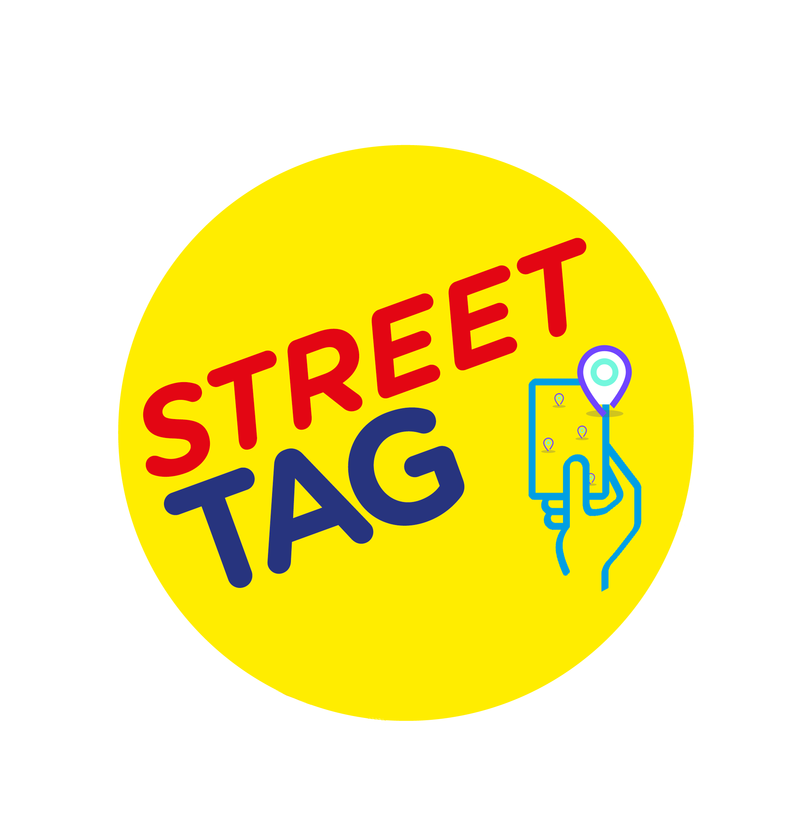

Street Tag
We are delighted to announce that Longfields will be participating in the Street Tag Oxfordshire Schools Games for the second season, which will be starting after the Christmas Holidays.
About Street Tag
- For communities, Street Tag is exceptional at bringing together families, neighbors, and communities to get out more, by turning streets and green spaces into a virtual playground, to increase families' outdoor experience in walking, running, and cycling more to earn rewards.
Step by step of how to participate in Street Tag and how it works
- Install the Street Tag app on the App Store or Play Store (or at www.streettag.co.uk)
- Join the school team using QR code.
- There can be up to 250 players in our school team.
- During the Street Tag experience, families, staffs, and children record their distance walked by scanning virtual tags (each tag are worth 10 points on average) at various locations, converting their steps done indoors or outdoors into pints through the steps sync feature, watching their total distance (points) accumulate to climb up on the School leaderboard, creating competition, being physically active, visiting parks, an opportunity to engage in a fun play experience, and earning prizes. Overall Street Tag delivers active happiness to families.
- There will be prizes for the top 3 schools on the leaderboard.
Vouchers worth 50 GBP for 1st, 2nd, 3rd positions respectively.

Schools QR Code

If you have any questions, please send an email to seun@streettag.co.uk

